Variables and Definitions
These are the statistics used from submitted casual mode match histories. The following notation will be used:
T_{C} – connection time -> This is when the player first establishes connection with a Valve server, which is when the popup notification appears on the main menu (the green join button).
T_{Q} – time in queue -> This is the time a player spends in queue, recorded in seconds.
T_{E} – match end time -> This is the time the match ends, regardless if the player is in the server.
T_{L} – time left match -> This is when the player disconnected from the server. If the player remains until T_{E}, then T_{L} is automatically recorded as T_{E} by the match history.
T_{S} – time in server -> This is the total amount of time spent in the server, from when the player first establishes connection, until they disconnect or the match ends.
MD – match duration -> this is how long the casual match lasted, in seconds, regardless if the player was in the server. Duration starts once the ~60 second pre-round timer ends (when the match doors open), and ends once the final round ends. Humiliation periods (the 15 second periods after each round where the winning team gets to kill the losing team) are not recorded by the match duration. Why? No clue. It’s just how Valve made it behave.
P_{P} – total potential playtime in a match -> this is the total amount of playtime casual mode would have offered in a match if a player joined a match from the very beginning (before the pre-round timer ends).
P_{A} – actual playtime in a match -> this is the total amount of playtime players actually experienced in a casual match.
1) Data Cleaning
The raw data contains bad data points, which are removed. Casual match histories also record competitive/MVM matches, which are also removed. Once completed, the initial sample size was 9,861,609 matches.
I’m only interested in how casual mode currently functions. Therefore, I omit matches that occurred before March 28th, 2018 (aka the Blue Moon update). This was the last major change Valve made to the matchmaking system, introducing the Glicko-based matchmaker. Since casual mode was fundamentally different before this date, matches before this date do not reflect modern day functionality. This takes the sample size from 9,861,609 matches to 8,165,510 matches.
2) Map Popularity
Popularity by volume is simply how many times each individual map is played. Popularity by frequency is taken as how often each map is player per week, on average.
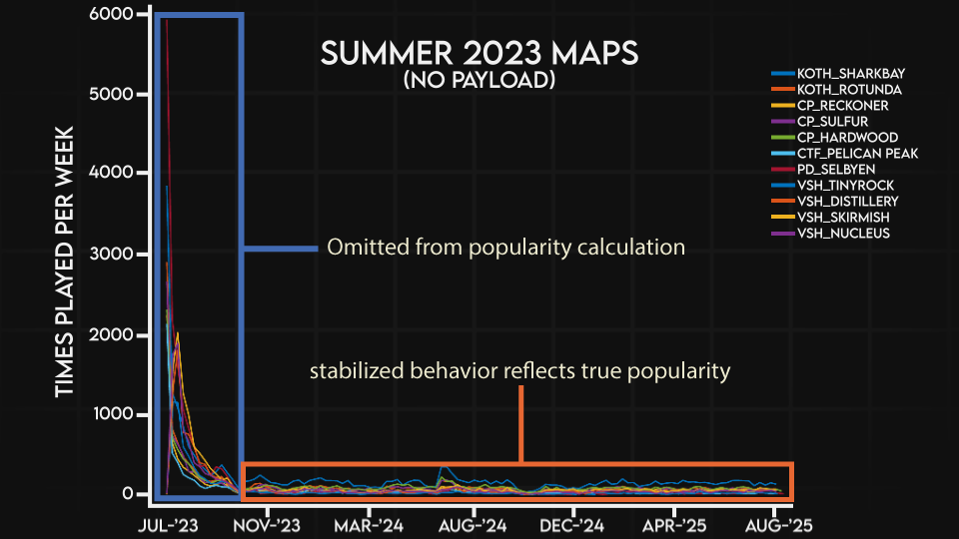
This is calculated by taking a 7-day moving average window on the time series, then an average of all 7-day windows. For maps added after March 28, 2018, I trim off the initial ~6-week period when the map was first added (Fig 1). This is because map popularity trends abnormally high from update hype/novelty, which skews the true popularity to be higher than it actually is.
Fig 1. Example of data used for popularity calculation
A full list of map rankings is shown in popularity_rankings.csv (see google drive folder). Note: the cutoff for my data collection was November 2025, meaning I did not have enough data to calculate popularity for the Summer/Winter 2025 maps. Hence, they are not included in this study.
3) How Often Players Stay for the Server Reset
As stated in the video, it is very easy to calculate how often players remain in the server for the reset (after the map vote). If T_{Q}=0, then the player remained in the server for the reset. They did not queue for this match, hence, 0. Any amount of time spent in queue, inside or outside of a server, results in T_{Q}>0. This was confirmed by actually playing the game and checking my own match history.
4) How Often Players Join Ongoing Games
Calculating how often players join ongoing games requires knowing P_{p} and T_{S}.

P_{p} is simply the MD added to the humiliation time in-between rounds. MD excludes humiliation periods between rounds, so I simply add those seconds back in (final red and blu team scores from the casual match histories, multiplied by 15 seconds). I think it’s safe to say that everyone considers the humiliation periods IN BETWEEN rounds as part of actual playtime, and the FINAL humiliation period as the end. Most people disconnect during this final humiliation period anyhow. So, I exclude the final humiliation period’s 15 seconds from P_{P}.
Next- I need to calculate the amount of time you spent in the server, T_{S}. This not only includes your play time, but also the up to 10-second popup window, your loading time, and the pre-round timers, if so endured. Thankfully, this is also easy to calculate:
T_{S} = T_{E} - T_{C}
Now that I have P_{P} and T_{S}, I can calculate how often players join an ongoing game. If T_{S} <P_{P}, you joined an ongoing game. If T_{S} >=P_{P} than, then you joined a game before it started.
There is some error to this. I have no way to calculate how long it takes for players to load into the server and start playing. Remember, the time spent in the server begins as soon as you establish connection on the main menu or within another server.
This means I have this short buffer of non-playtime I can’t account for. So, in some cases, T_{S} is still longer than P_{P}, but they actually started playing after the match began- hence here I over-estimate playtime, and log that as joining before the game started. Oppositely, in all cases where T_{S} <P_{P}- I again, over-estimate playtime, because I can’t clip out loading times.
Unfortunately, I can’t do anything about this. Plus, for my critics out there- both of these errors are in favor of casual mode providing more playtime, and offering more matches from the beginning, so none of my own biases against casual mode are being reinforced here.
4) Match Abandonment Rate
Since I’m interested in experience casual mode provides, I need to exclude matches in which players abandoned their game. They willingly cut their playtime short, and did not experience the full playtime casual mode would have offered them.
This is quite easy to do. A match is considered abandoned if if T_{L} occurs before T_{E}I used a threshold of 10 seconds- if you left within 10 seconds of the match ending, I did NOT count that as an abandonment. This takes the sample size from 8,165,510 matches -> 4,649,041 matches. This also means the 42% abandonment rate shown in the video is a conservative figure.
5) True Playtime in a Match
Using the remaining 4,649,041 matches in which players did not abandon their games, I calculate the true, actual playtime in each match that casual mode offered (P_{A}). If you joined a match at the beginning, meaning T_{S} >= P_{P}, then P_{A}= P_{P}. If you joined an ongoing match, then P_{A}= T_{S}. Because I can’t account for loading times, all P_{A} calculated are GREATER than what they actually are, again, overestimating true playtime. In other words- your playtime is actually LOWER than what is shown in the video.
Medians and averages are calculated using Matlab’s built in functions, these basic statistics are easily performed using Excel/Python as alternatives.

