The following document contains screenshots of twitter users discussing relationships they previously had with Nikolay Dybowski, founder and current head of Ice Pick Studios, while they were underage and he was in his 40s. The women involved in these screenshots were between the ages of 15-16 when their relationships with him began. Dybowski is best known for the creation of and his subsequent involvement of the Pathologic games. Dybowski has been employed at HSE University since 2017, and his current wife was allegedly at one point one of his students.

The users involved have reached out after the allegations first started circulating in English speaking Pathologic circles. They have requested to remain anonymous for their own safety, as in the past women who have been involved with Dybowski have been harassed. Do not attempt to locate the original twitter threads. Doing so would be highly immoral and could put these women at risk.

They were not aware at the time that these twitter conversations would be used as evidence and were found by someone who heard allegations of Dybowski’s actions. I received confirmation that it is alright to share these publicly.

I am not a Russian speaker. The tweets have been translated with google translate, and thus may not be entirely accurate or easy to understand, however fluent speakers have confirmed that they are generally correct. I have kept the original Russian for posterity.

The following screenshots contain discussions of CSA and graphic language.
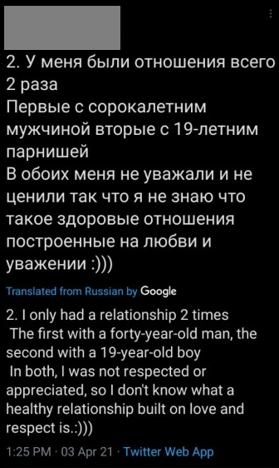
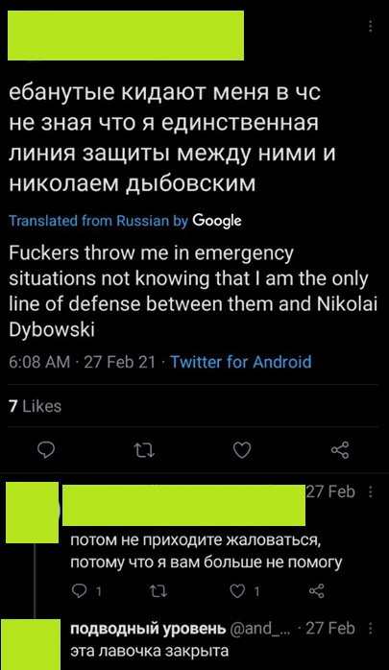
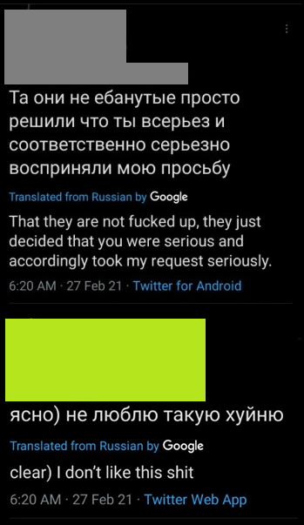
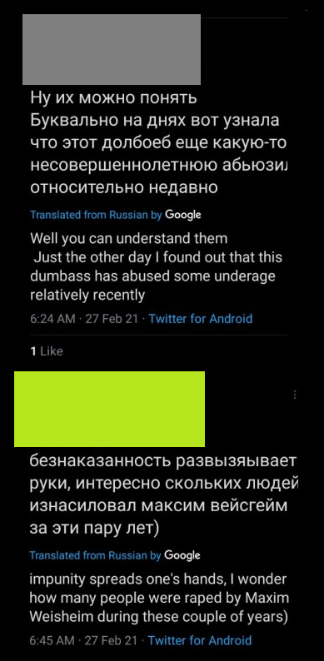

The grey user above has been in touch with me privately and has confirmed that the person being alluded to in these tweets is in fact Dybowski. The user confirmed that they were in a relationship with him between the ages of 15-18. I verified with them to make sure the above tweets were alright to share publicly.

I have as of yet been unable to get in touch with the other people in the screenshots below, so please use judgement and compassion when sharing these sections.

Many other Russian-speaking twitter users have spoken up about being at least somewhat aware of these allegations. Here is one such thread. These allegations appear to have started surfacing around 2012, to the best of my knowledge.

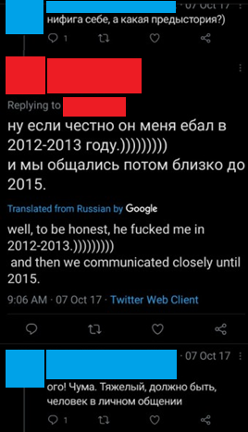
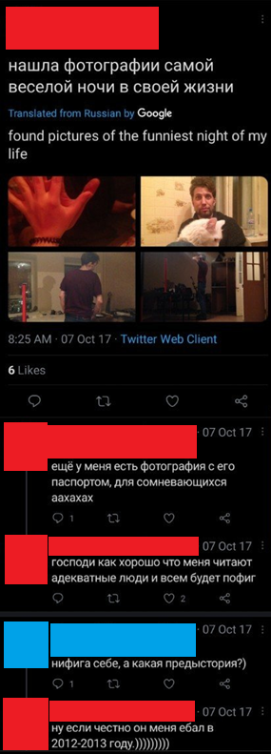
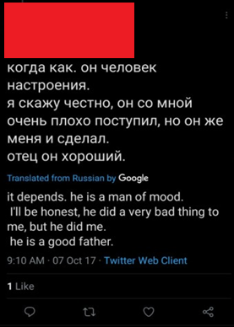

The following screenshots can either not be proven to be made by the victims, or are second hand testimony, however they contain information that helps paint a picture of the kind of person Dybowski is. It appears from an external perspective that many circles are well aware of Dybowski’s behaviour, but receive backlash when they speak out.



